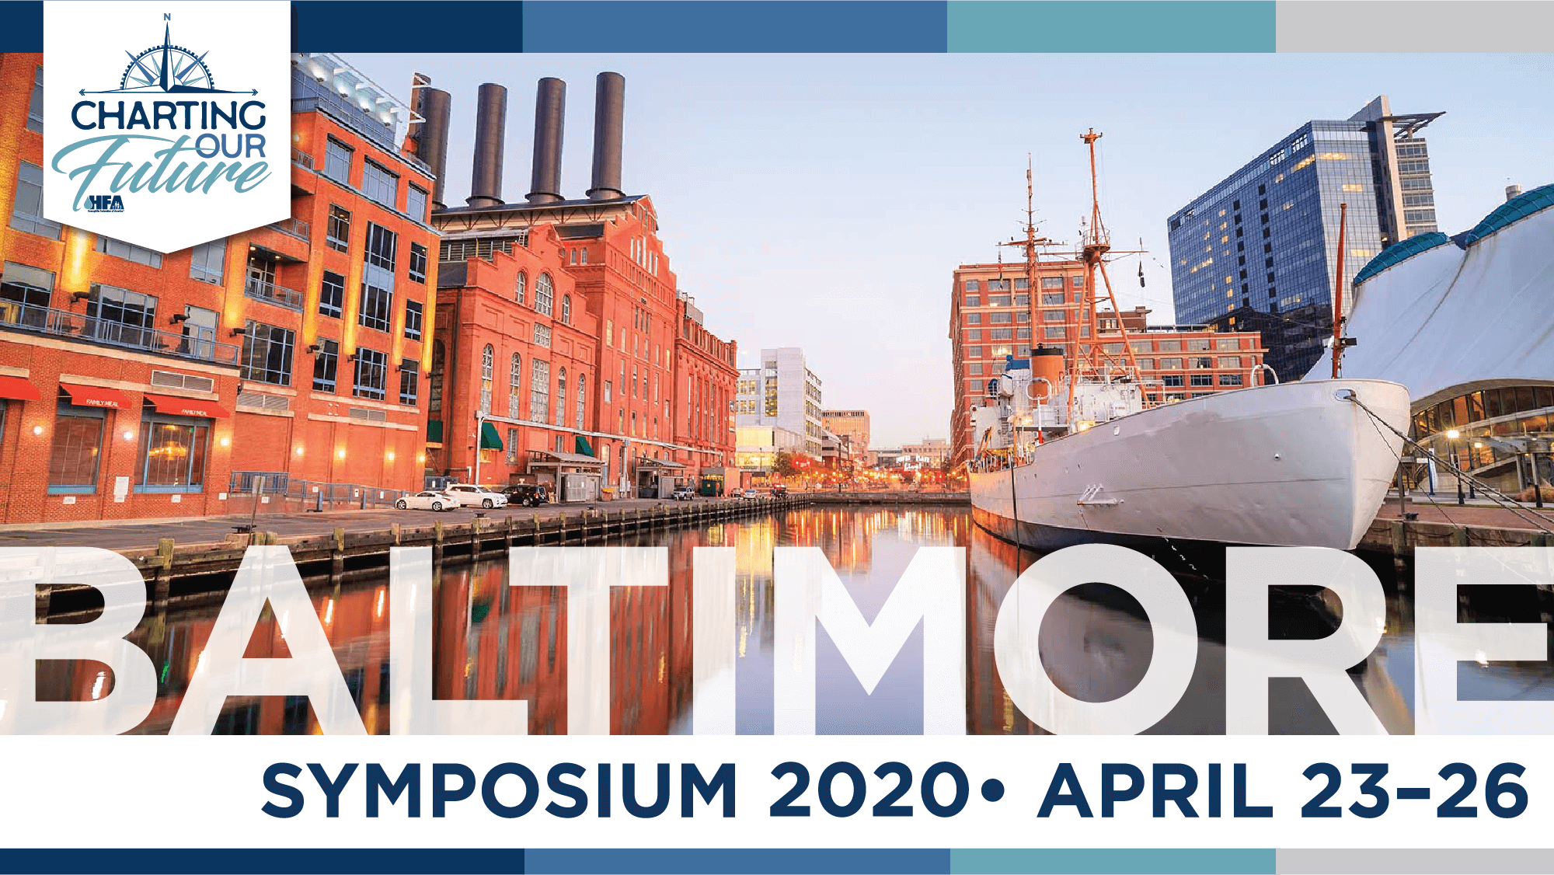
SWOHF SCHOLARSHIP APPLICATION FOR
2020 HEMOPHILIA FEDERATION OF AMERICA SYMPOSIUM
BALTIMORE, MARYLAND – APRIL 23-26, 2020

APPLICATION MUST BE RECEIVED BY SWOHF by November 21, 2019
SWOHF is pleased to offer the scholarship opportunity for one individual in our community who is affected by a bleeding disorder and an immediate family member to attend the HFA Symposium in Baltimore, Maryland on April 23 to 26, 2020. Application may be mailed, faxed, emailed or hand delivered to:
Southwestern Ohio Hemophilia Foundation
Attention: Kay Clark
3131 South Dixie Drive #103
Moraine, OH 45439
FAX 937-298-8080 OR Email kay@swohf.org
HFA’s Symposium is an annual community-centered educational event that draws hundreds of members from the bleeding disorders community together to share information, learn new advancements and build a network of support!
For more information on this meeting, please visit their website: www. hemophiliafed.org and click on Programs, Events, Symposium.
This scholarship award is intended to solely cover:
• Registration to the 2020 HFA Symposium
• Travel
• Hotel Accommodations
The scholarship is open to all individuals affected by a bleeding disorder who live in the Greater Dayton area. We are excited to have the opportunity to offer this scholarship and are confident that the family selected to attend will come back with greater knowledge and enhanced empowerment!
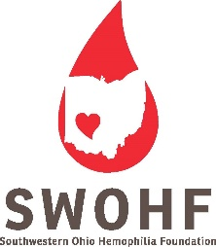 SWOHF TRAVEL SCHOLARSHIP APPLICATION
HFA SYMPOSIUM – BALTIMORE, MARYLAND 4/23-26/2020

Name of Applicant: ________________________________________________________________________
Date of Birth/Age of Applicant: ___________________
Name, Relationship and Date of Birth of Immediate Family Member Attending with Applicant:
_________________________________________________________________DOB:___________________
Type of Bleeding Disorder of Applicant: ________________________________________________________

Full Address: _____________________________________________________________________________
Home Phone Number: _____________________________________________________________________
Cell Phone Number: _______________________________________________________________________
Email: ___________________________________________________________________________________
Have you ever attended an HFA or NHF Conference? _____________________________________________
Have you ever received a scholarship to attend NHF or HFA Conference? _____________________________

PLEASE ANSWER THE FOLLOWING QUESTIONS (Use additional paper if more space is needed)
1. Why is it important for you to attend HFA’s Symposium?
__________________________________________________________________________________________________ __________________________________________________________________________________________________ __________________________________________________________________________________________________ __________________________________________________________________________________________________ __________________________________________________________________________________________________

2. What do you hope to gain by attending HFA’s Symposium? __________________________________________________________________________________________________ __________________________________________________________________________________________________ __________________________________________________________________________________________________ __________________________________________________________________________________________________ __________________________________________________________________________________________________

3. How will you and your family member take the information gained from the HFA Symposium and share it with others in the community who were unable to attend? __________________________________________________________________________________________________ __________________________________________________________________________________________________ __________________________________________________________________________________________________ __________________________________________________________________________________________________

4. Are you currently participating in activities sponsored by SWOHF? __________________________________________________________________________________________________ __________________________________________________________________________________________________ __________________________________________________________________________________________________ __________________________________________________________________________________________________

5. Is there any other important information you would like to share? __________________________________________________________________________________________________ __________________________________________________________________________________________________ __________________________________________________________________________________________________ __________________________________________________________________________________________________

I understand that this is an open application to families of the SWOHF community in the Greater Dayton area only and that all applicants may not be awarded a scholarship to attend. If I am granted this scholarship, the award is solely for direct expenses used for attendance to HFA’s Symposium 2020 and an application must be completed requesting HFA hotel scholarship if possible. Travel expenses and hotel will be paid directly by SWOHF. Before you apply, please be aware that there will be other costs to attend; for example: meals, taxi/shuttle, baggage, and other miscellaneous expenses. SWOHF is not responsible for any additional expenses of the trip.
If granted the award, I agree to:
• Attend all education sessions available throughout the entire conference
• Take notes and gather handouts to bring back to SWOHF
• Be willing to write an article about my experience to be published in the “Factor Notes” newsletter and/or talk about my experience at our SWOHF Annual Meeting 2021.
I consent that the Southwestern Ohio Hemophilia Foundation is not liable for any loss, damage or harm caused during travel and/or during HFA’s Symposium.
Signature of Applicant or Parent/Guardian if under age 18:

____________________________________________________________________ Date: ______________________
Please print name here: ___________________________________________________________________________
** APPLICATION MUST BE RECEIVED in office by November 21, 2019 **

